Linked List

Linked List is a very commonly used linear data structure which consists of group of nodes in a sequence.
Each node holds its own data and the address of the next node hence forming a chain like structure.
Linked Lists are used to create trees and graphs.

Advantages of Linked Lists
– Dynamic in nature which allocates the memory when required.
– Efficient memory utilization
– Insertion and deletion operations can be easily implemented.
– Stacks and queues can be easily executed.
– Linked List reduces the access time.
– don't need to know the size in advance.

Disadvantages of Linked Lists
– require extra memory for pointers storage.
– No element can be accessed randomly; it has to access each node sequentially.
– Reverse Traversing is difficult in linked list.

Applications of Linked Lists
– Implementation of stacks and queues
– Implementation of graphs

Types of Linked Lists
There are 3 different implementations of Linked List available, they are:
- Singly Linked List
- Doubly Linked List
- Circular Linked List

Singly Linked List
Singly linked lists contain nodes which have a data part as well as an address part i.e. next, which points to the next node in the sequence of nodes.

Doubly Linked List
In a doubly linked list, each node contains a data part and two addresses, one for the previous node and one for the next node.

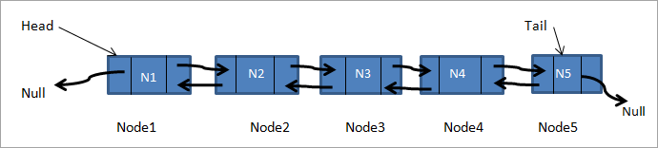

Circular Linked List
In circular linked list the last node of the list holds the address of the first node hence forming a circular chain

